“BODHA”~   
An insight to Cognizant Digital Engineering

BODHA APP URL:

<http://bodha-dev.app.dev.digifabricpcf.com/> (DEV)

<http://bodha.app.dev.digifabricpcf.com/> (PROD)

GITHUB URL FOR BODHA UI:

<https://github.com/TheCognizantFoundry/OnboardingPortal-UI>

BRANCHES: a) Master (Points to PROD)

b) MVP5 (Points to DEV)

TECHNOLOGY STACK- BODHA UI:

* React JS, Redux, GitHub, PCF

BODHA UI CODE ORGANIZATION:

* CODE STRUCTURE

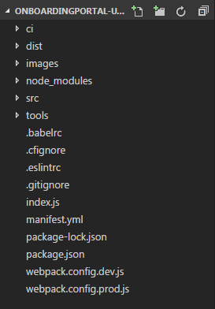

* THE SOURCE FOLDER (src)

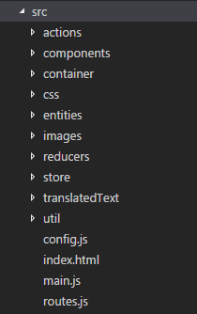

* The entire UI shall be split into independent reusable pieces called ‘Components’. We have maintained the components for the screens in the folder ‘components’. (src 🡪 components)

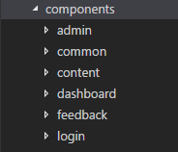

* The state of our application is maintained in the ‘Store’ which can be altered via ‘Actions’. These actions have been written separately for various components and maintained separately in the folder ‘actions’. (src 🡪 actions)

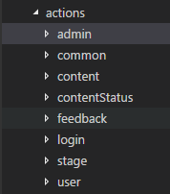

* The custom styles and widgets are maintained in the ‘css’ folder. (src 🡪 css)

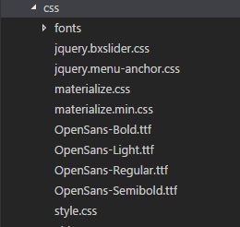

* The images we see at various places in the App are maintained in the ‘images’ folder. (src 🡪 images)

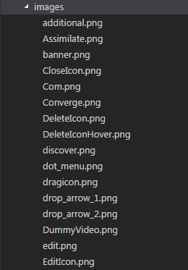

* To specify how the application's state changes in response to [actions](https://redux.js.org/basics/actions) sent to the store, we use reducers which are maintained in the folder ‘reducers’. (src 🡪 reducers)

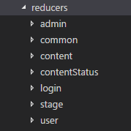

* TESTING

We have utilized the ‘nock’ npm library and ‘redux-mock-store’ for testing our modules.

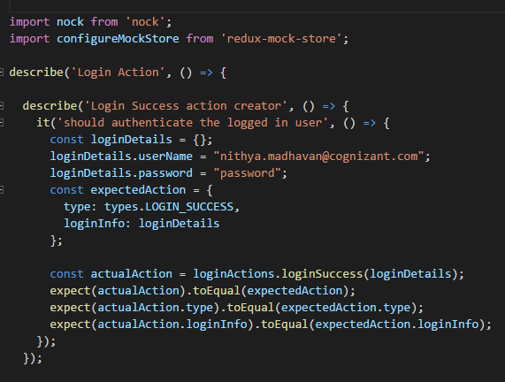

* BUILD AND DEPLOYMENT

When we build the app to be able to deploy it to PCF, the contents of the ‘dist’ folder shall get updated.

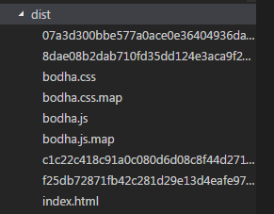

* Manual Deployment

Follow the below steps for the manual deployment of the BODHA UI   
 into PCF:

* Download the ‘Onboarding’ folder attached along with this document.
* In the command prompt, go to the source path that contains your latest code.
* Run the following command:

**“npm run build”**

(This command will be executed successfully only if the ‘node_modules’ folder is   
 present in your source path. If it isn’t, run **‘npm install’** prior to ‘npm run build’.)

* On running the above command, the contents of the **‘dist’** folder in your source code folder get updated.
* Copy the contents of this updated ‘dist’ folder and replace the ‘dist’ folder which is present in the ‘Onboarding’ folder that you downloaded.
* The ‘Onboarding’ folder contains two files that have to be altered as per the space we are pushing our app into. Following are the required changes:

1. ‘**manifest.yml’**

                                                                                           DEV-         **name**: bodha                                    
    **host**: bodha-dev  
  
 PROD-      **name**: bodha              
 **host**: bodha             

1. **‘bodha.js’** (inside the dist)

                            DEV- **domainUrl**: <https://bodhaapijsoningnore.app.dev.digifabricpcf.com/>

                           PROD- **domainUrl**:  <https://bodhaapi.app.dev.digifabricpcf.com/>

* Log in with your PCF credentials.
* Keeping the source path as the path of the ‘Onboarding’ folder, do a **‘cf push’** in the respective spaces, i.e. DEV or PROD.
* UI Pipeline

